Tax Morale in Africa

Wiebke Weiger & Jasmin Cantzler

23 October 2015

#### 1. Overview: Introduction & Policy Relevance, Research Question, Data Sources & Preliminary Structure of Collaborative Research Project

**Introduction & Policy Relevance:** Tax evasion is considered a social malady across countries and is often thought to be one of the bigger obstacles to inclusive economic growth. High levels of evasion lead to a misallocation of resources and hinder the ability of the government to invest in the provision of public goods. Therefore, understanding the rationale driving tax evaders as well as tax compliers becomes essential to national development and state-building. Identifying and conceptualizing patterns will open the possibility for governments to effectively and efficiently tackle tax evasion. The current tax compliance literature lacks empirical evidence on the degree of tax morale in developing countries. This paper's aim therefore is to tap into this gap by studying tax morale in African countries. The paper will attempt to investigate the determinants that systemically affect tax morale using data for 34 African countries from the Afrobarmoeter.

**Research Question:** What are the determinants of tax morale in Africa?.

**Data Sources:** The data we will use to investigate this question is provided by the [Afrobarometer](http://www.afrobarometer.org/) and freely available for the years 2015 (34 countries), 2008 (20 countries), 2005 (18 countries), 2004 (16 countries) and for the years 1999-2001 (12 countries).

The data is downloaded directly from the Afrobarometer's website into R using the following code:

main <- rio::import("http://afrobarometer.org/sites/default/files/data/round-5/merged_r5_data_0.sav")

**Preliminary Structure of the Final Paper for the Collaborative Research Project:**

1. Introduction
2. Literature Review
3. Data & Method
4. Results and Discussion
5. Conclusion

#### 2. Literature Review and Research Gap Identification

In 1972, Allingham and Sandmo presented a formal model explaining tax evasion as a negative correlation with the probability of detection and the degree of punishment (Allingham and Sandmo 1972) . According to their model, rational individuals should report virtually no income. In later years, their model turned out to have little explanatory power and failed to explain the high degree of tax compliance in some countries despite their low level of deterrence. This puzzle of tax compliance and the limitations of deterrence models led to an increasing literature acknowledging the need to consider other non-economic factors, such as psychological, moral and social factors. One widely used concept to be included in the economics of crime model is that of tax morale. Tax morale is often defined as "the existence of an intrinsic motivation to pay taxes" (Torgler 2005; Torgler and Schneider 2009; Cummings et al. 2009). While there are many other definitions out there, this is the one most commonly used.

Despite the absence of a common definition of tax morale, there seems to be an agreement on certain drivers, in particular social norms, values and trust and/or approval of the government seem to have an effect on tax morale. There is strong evidence that tax morale influences tax compliance of individual taxpayers (Maciejovsky, Schwarzenberger, and Kirchler 2012; Molero and Pujol 2012; Dulleck et al. 2012).One of the major shortcomings of the current literature debate is that little research has been conducted in developing countries. This research paper thus aims to (at least partially) close this gap by investigating the determinants of tax morale in African countries.

#### 3. Research Design & Methods

African countries, while different on their own, share certain characteristics, such as colonial past, that render them comparable (work on that argumentation) For the purpose of this project â to analyse a region-, specific institutional and contextual characteristics of the countries will not play a prominent role. On the other hand, emphasis will be put on their shared socio-economic characteristic of being developing nations. The direct consequence of this is that they present low tax-effort indices â revenue collections to estimated revenue potentials â and, therefore, the importance to tackle tax evasion (and avoidance) becomes more urgent. **add tax effort graph Africa**

Moreover, identifying the determinants of tax morale could have interesting implications for policy interventions in compliance matters. For example, studies have shown that (pre-existing) deterrence mechanisms work better when there is a "social cost" attached to them (OECD –). With a thorough literature review, we will argue that this "social cost" can be explained by tax morale. Hence, policy strategies aiming at increasing compliance should look at ways of increasing tax morale, appealing to the cooperative (complier) side of the sector, as opposed to increasing deterrence mechanisms which may have counter-intuitive effects â such as more evasion, even when the cost of defecting increases.

In order to carry out the analysis, we will use data from the Afrobarometer, an "African-led, non-partisan survey research project that measures citizen attitudes on democracy and governance, the economy, civil society, and other topics" (insert quote) The Afrobarometer's main donors for the survey rounds 5 and 6 (data on round 6 are not available yet) included the Mo Ibrahim Foundation, the Swedish International Development Cooperation Agency, the Department for International Development, the United States Agency for International Development, as well as the World Bank.

**Figure 1: Countries included in the Afrobarometer** 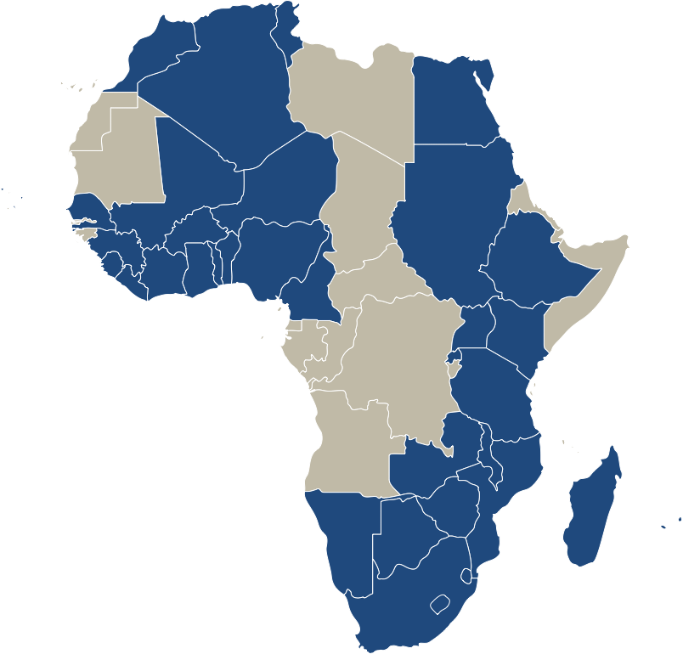

For this particular project, we will use the variable "People must pay taxes" from the dataset as the dependent variable. The information on this variable is obtained by asking the following question: "please tell me whether you disagree or agree: The tax authorities always have the right to make people pay taxes". The variable is coded as a categorical variable with values from 1 to 5 ("strongly disagree" to "strongly agree"). The questionnaire includes more variables that could be used to operationalize the dependent variable, but this particular variable has the advantage that it is asked in the same way for the waves of 2004, 2005, 2008 and 2015 (waves 2-5).

We will use findings from a similar study by Benno Torgler (2005) who has identified factors that systematically affect tax morale in Latin America to test whether we can find similar patterns for African countries as well. Accordingly we will test the hypothesis that a pro-democratic attitude and trust in political and government institutions have a positive effect on the level of tax morale.

In order to test our hypothesis we will perform a multivariate regression analysis with year dummy variables. In accordance with some general findings from the tax morale literature we will control for socio-economic factors that have been found to be associated with the level of tax morale. These include for example gender (being female has been found to be associated with higher tax morale), age, education, employment status and being religious.

*In order to gain some more insight into whether policies aiming at increasing tax morale in developing countries work, we will attempt to identify such policies (e.g. campaigns) during the time frame in one or some of the countries covered by the Afrobarometer. If we find such a policy then we can take advantage of the pooled cross sectional character of the dataset. As we would have data collected before and after such a policy, we can estimate its effect on tax morale.*

# References

Allingham, Michael G., and Agnar Sandmo. 1972. “Income tax evasion: a theoretical analysis.” *Journal of Public Economics* 1 (3-4): 323–38. doi:[10.1016/0047-2727(72)90010-2](http://dx.doi.org/10.1016/0047-2727(72)90010-2).

Cummings, Ronald G., Jorge Martinez-Vazquez, Michael McKee, and Benno Torgler. 2009. “Tax morale affects tax compliance: Evidence from surveys and an artefactual field experiment.” *Journal of Economic Behavior and Organization* 70 (3): 447–57.

Dulleck, Uwe, Jonas Fooken, Cameron Newton, Andrea Ristl, Markus Schaffner, and Benno Torgler. 2012. “Tax Compliance and Psychic Costs: Behavioral Experimental Evidence Using a Physiological Marker.” *CREMA Working Paper Series*. Center for Research in Economics, Management; the Arts (CREMA). <http://ideas.repec.org/p/cra/wpaper/2012-19.html>.

Maciejovsky, Boris, Herbert Schwarzenberger, and Erich Kirchler. 2012. “Rationality Versus Emotions: The Case of Tax Ethics and Compliance.” *Journal of Business Ethics* 109 (3): 339–50.

Molero, Juan Carlos, and Francesc Pujol. 2012. “Walking Inside the Potential Tax Evader’s Mind: Tax Morale Does Matter.” *Journal of Business Ethics* 105 (2): 151–62.

OECD. –. “Forum on Tax Administration: Small/Medium Enterprise (SME) Compliance Subgroup. Understanding and Influencing Taxpayers’ Compliance Behavior (Information Note).”

Torgler, Benno. 2005. “Tax Morale in Latin America.” *Public Choice* 122: 133–57.

Torgler, Benno, and Friedrich Schneider. 2009. “The impact of tax morale and institutional quality on the shadow economy.” *Journal of Economic Psychology* 30 (2): 228–45.